Project name: clinic plus
Project sponsor:
Medtronic

Team leader:
Yousry Essam

Team members:
Youssef Mohammed Abbas Abdelwhab.
Youssef Mohammed Morsy.
Mohamed mafaz.
Abdo Refaat Abdo.

Executive summary
The problem of lack of money and the time to go to the doctor to be examined is one of the most important problems that face us nowadays. As the prices of doctors’ examinations have risen dramatically, in addition to wasting a large amount of time waiting. Moreover, that there is lack in number of medical staff because of corona virus pandemic. So, efforts must be made to solve such a problem.
This problem can be solved by creating an application that define schedule doctors’ appointments, reduce prices on specific days and determines doctors’ working hours. As well as determining wages and who are the best doctors in various specialties, another feature that allows the patient to write simple symptoms, can dispense medicines and decrease the crowd medical centers

Project scope:
1-Web application 2-Android application
3-IOS application 4-Applications design
Out of scope:
- Training of app users
- Marketing application
WPS
- Design
1.0 web app
1.1 Android app
1.2 IOS app
2- software
2.0 Back-End design
2.1 Coding Android app
2.2 Coding IOS app
2.3 Software debugging

Project objectives:
- Save time for the patient and the doctor
- Facilitate patient communication with the doctor
- There are a large number of doctors with different assessments, which allow the patient to choose the doctor that suits him and the recommendations of previous patients
- Minimize direct contact to maintain public safety
Constraints:
project must be delivered before 1 / 2 / 2022
Hour of working starts at 8 AM to 3 PM
Deliverables:
- Design application
- Software industry
- application working on all platforms ( web, android, ios, macOS, windows)

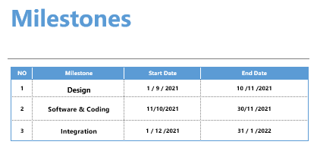

Responnsibelity matrix

Network Expert | QA_tester | Network Engineer | App Developer | Project Manager | Task/Member
 | I | I | C | A | Create web app
 | I | C | R | A | Create android app
 |  | R | I | C | Create IOS App
 | R | C | C | I | Backend formation
C | A |  | C | R | Coding Android App
R | A |  |  | I | Coding IOS App
C | R |  | C | A | Software debugging

RACI:
Responsible: person who is completing the task.
Accountable: person who is making decisions and taking actions on the task.
Consulted: person who will be communicated with regarding. decision-making process and specific tasks.
Informed: person who will be updated during the project

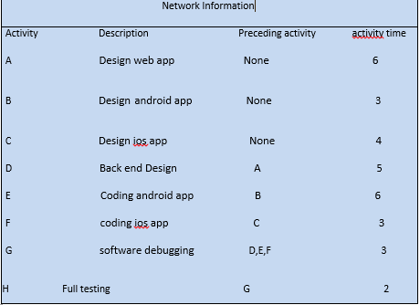

Project Network

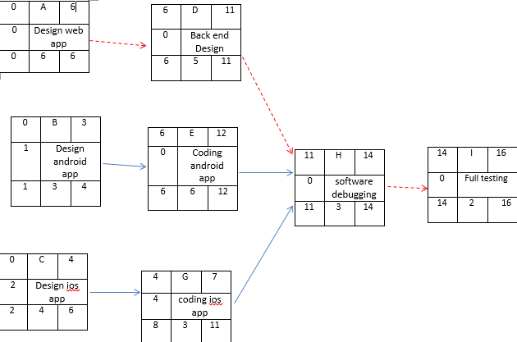

Gantt chart

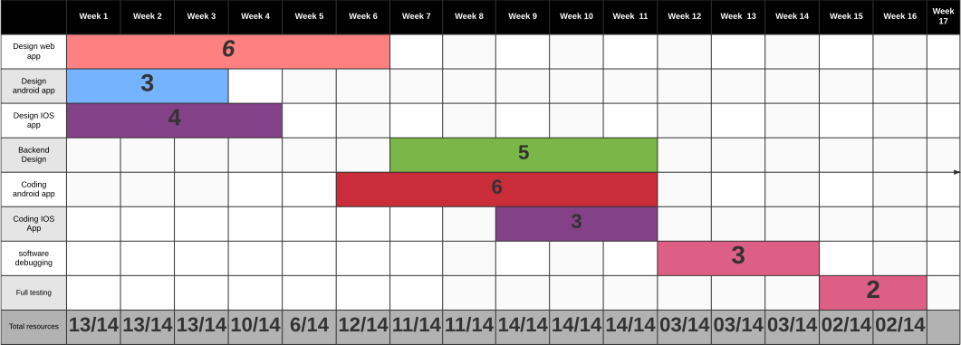

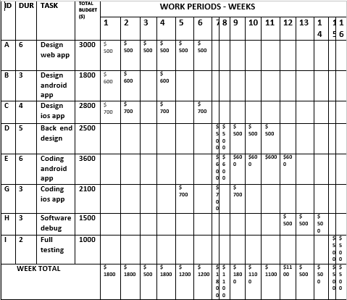
time phase budget

budget
- Design web app:3000$
- Design android app:1800$
- Design iOS app:2800$
- Backend design for web app: 2500$
- Coding android app: 3600$
- Coding iOS app: 2100$
- Software debugging: 1500$
- Full testing: 1000$

Main causes | Sub causes | solutions
1-Bad timing. | 1.1-  the time for the project was initially incorrectly calculated and set  1.2-  the project manager does not properly track employees, skills, task status  1.3-  the functional features of the final product were not determined in a timely manner;  1.4-  unexpected and urgent expansion of the project scope  1.5-  lack of resources. | ensure the maximum involvement of all team members in planning and estimating, receive feedback at all stages, starting from the earliest ones, involve the Owner or Stakeholders.
- Incorrect budget estimation. | 2.1-  the budget was initially calculated incorrectly.  2.2-  no funds have been reserved.  2.3-  unplanned project expansion. | It is necessary to maintain constant control of the budget and development process. When introducing additional functions – or the need for any changes – calculate their cost at the discussion stage.
3-poor code quality and technical risks. | 3.1-  lack of professionalism and knowledge of team members.  3.2-  constant changes in software requirements.  3.3-  the technology used does not have a sufficient level of development and community support (it cannot provide the necessary functionality).  3.4-  too complex multi-part project.  3.5-  the implementation of project modules turned out to be more difficult than expected. | Choosing professional cadres capable of doing this task or it will not be possible to completely avoid risks –only to mitigate them.
4-user engagement | 4.1-  insufficiently deeply conducted research to identify the target audience of the project and its needs.  4.2-  incorrectly selected solution for the key needs of the target audience.  4.3-  poorly thought out, outdated, or not engaging product UX/UI design. | deep analysis of the needs of the finished product’s target audience, which is carried out by professional business analysts. This also allows taking into account certain features when developing the appearance and usability of the product.
- Poor management | 5.1-  poor communication and interaction within the team.  5.2-  insufficient qualification level of PM.  5.3-  lack of leadership and analytical skills.  5.4-  poor risk management in software development. | high standards are always set for the project manager. He must combine the traits and skills of a strategist and tactician, be deeply involved in the project, effectively communicate with the team, build a strong organizational framework, and implement elaborate documentation processes.
- Poor productivity. | 6.1-  poor project management.  6.2-  incorrectly chosen methodology.  6.3-  incorrectly matched team members. | using agile methodologies allows to maintain the productivity and motivation of all team members throughout the project since the processes are divided into shorter periods of time.
- Unpredictable risks. | 7.1-  sudden market changes.  7.2-  the fast growth of a competitor (with more resources available).  7.3-  implementation of new government regulations.  7.4-  changes in consumer behavior and priorities. | Hire a business analyst ,His tasks include research the market, country of operation, and worldwide tendencies to analyze the current situation.
8-Inadequate Human Resources. | Though unlikely, occasionally a stakeholder or development team member must leave a project unexpectedly. | Maintain up-to-date documentation.  On-board new or replacement stakeholders with a learning guide; and  Monitor the invoice schedule and team utilisation frequently.

